***Project overview***

***Background***

Wilmington University is a private, non-profit, doctoral research institution with its main campus located in New Castle, Delaware, United States. The university serves a total student body of 20,522 undergraduate and postgraduate students in nearly 100 degree and certificate programs. The university's programs are offered at its main campus in historic New Castle as well as at six additional campuses in Delaware, several partnership locations in New Jersey, and a single partnership location in northeastern Maryland.

***Problem Statement***

The university has a lot of locations as well as many students. Physical registration at the compass requires a lot of employees for helping students. At the other hand, it makes a lot of difficulties for students such as traveling, waiting for long lines. Online registration can avoid all inconvenience and confirm your desire course and subject from any part of the world and confirm your registration right away.

***Project Vision***

We envision getting every student at Wilmington University the ability to registrar for classes without any issue. Primarily, we will have created an amazing website that will allow them to search for three different degree programs that the university will offer. Each degree will require five classes which students will be able to select the course that they want to register for. The website will also produce a short description of each course as well. In each class, student will have the opportunity to see who the teacher is that’s assigned to the course. In this way students can make a decision and submit a request to register for the course and professor that they prefer or select a different one. At the end, the website will deliver a confirmation message to each student after they have selected a course with the assigned professor, schedule and associated cost.

***Success Criteria***

1. Utilizing GitHub to build registration website
2. Communicating with Agile team via Slack to complete task on time
3. System should be able to confirm registration via email
4. Working website should be done within promised time.

***Project Approach***

Scrum-an Agile Methodology

***Project plan***

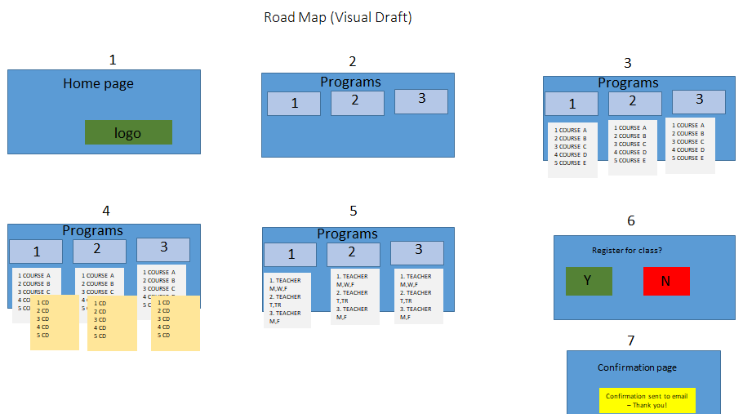

***Project Participants***

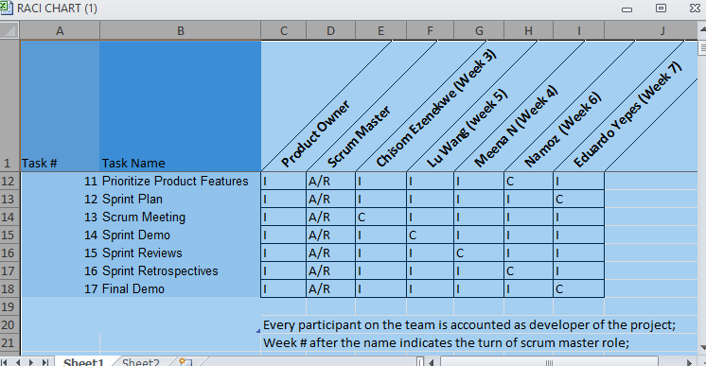

***Project Timeline Estimate- Release Plan***

|  |  |  |  |  |
| --- | --- | --- | --- | --- |
|  | ***Sprint 1 (Week 4)*** | ***Sprint 2 (Week 5)*** | ***Sprint 3 (Week 6)*** | ***Sprint 4 (Week 7)*** |
| ***Home page*** | ***Header;***  ***Graphic;*** |  |  | ***Revised text;*** |
|  | ***Program List*** |  |  | ***Contact Information;*** |
|  |  |  |  | ***Well arranged page setup;*** |
| ***Sub-page*** |  | ***Sub-pages for each program;*** | ***Class information;*** |  |
|  |  | ***Header;*** |  |  |
|  |  | ***Class List;*** |  |  |
| ***Functionality*** | ***Class Link for each program;*** | ***Submitting Button*** | ***Confirm information*** | ***Final testing done;*** |
|  |  |  | ***Confirmation Notice*** |  |
|  |  |  | ***Cost calculation*** |  |

***Constraints and impact***

|  |  |
| --- | --- |
| Constrains | Impact |
| Design should be simple and clear | It makes user easy to find what they want |
| Website should be published within GitHub | Program language might be limited |
| Pop up window should appear when user choose desired course to give an option | It gives some difficulties for web designed to code |

***Assumptions***

* Agile team should have an access to get an GitHub next 5 weeks
* Team member should complete assigned issues on time or inform Scrum master on time for necessary support

***Dependencies***

* Internet connection
* Github should be running within project period
* Each member prompt action on assigned issues

***Risk***

|  |  |
| --- | --- |
| Risk | Mitigation Strategy |
| Project is dependent on Github server | Save files for unexpected server crushes |
| Not enough coding knowledge and experience to build website | Make consistence researches, make time for online learning |